# **CHAPTER-2**

# **ANALYSIS**

## Requirement Analysis

* + - In present era, the importance of **Nursery Store** is growing up day by day, user needs a simple interface to order Plants online, this project **E-Nursery System** fulfills all the requirements of user and it provides an easy interface to navigate.
    - The customer can easily place orders for the Plants items of their choice. For ordering the Plants customer needs to register into the system with their details and after the registration, customer can filter out the Plants according to the placement, occasions, gift types.

## Project Model

When errors are detected at some later phase, these feedback paths allow correcting errors committed by programmers during some phase. The feedback paths allow the phase to be reworked in which errors are committed and these changes are reflected in the later phases. But, there is no feedback path to the stage – feasibility study, because once a project has been taken, does not give- up the project easily.

It is good to detect errors in the same phase in which they are committed. It reduces the effort and time required to correct the errors.

User can also give feedback, rating and can upload product images and it provides easy return policy if there any problem.

**Phase Containment of Errors:** The principle of detecting errors as close to their points of commitment as possible is known as Phase containment of errors.

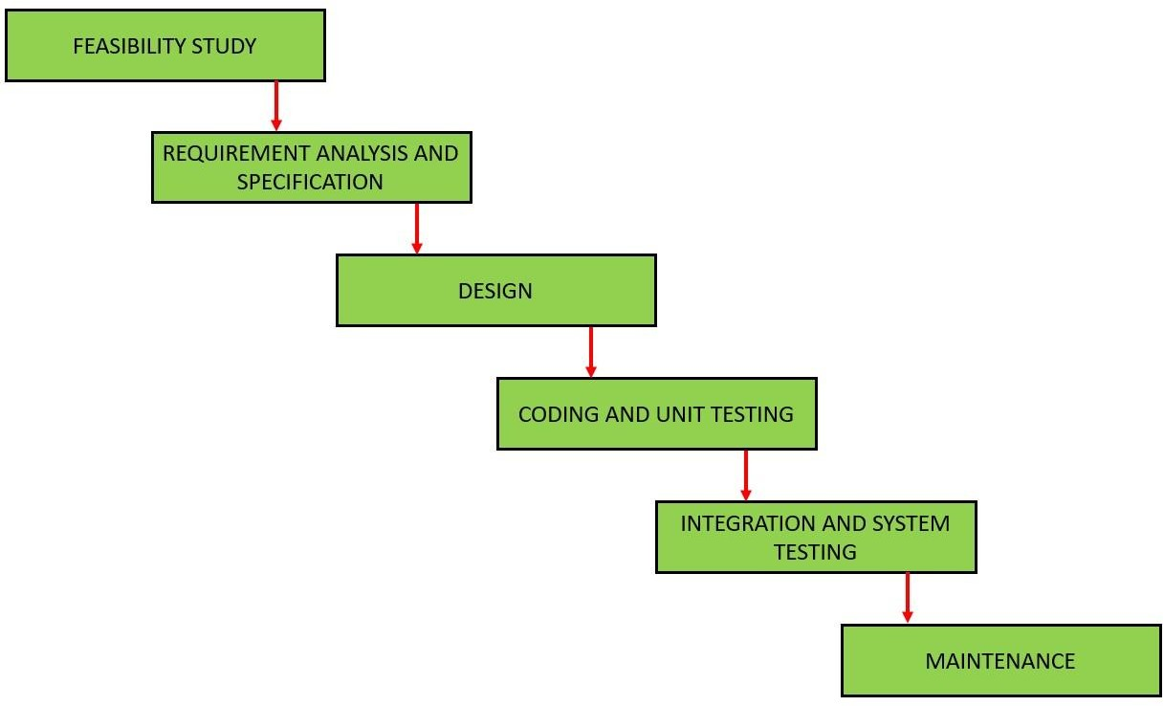

**[Figure 1: Project model]**

**Advantages of iterative waterfall model**

* + - **Feedback Path:** In the classical waterfall model, there are no feedback paths, so there is no mechanism for error correction. But in iterative

waterfall model feedback path from one phase to its preceding phase allows correcting the errors that are committed and these changes are reflected in the later phases.

* + - **Simple:** Iterative waterfall model is very simple to understand and use. That’s why it is one of the most widely used software development models.
    - User gets a chance to experiment with partially developed software.
    - This model helps finding exact user requirements.
    - Feedback providing at each increment is useful for determining the better final product.

## Schedule Representation

* + - Generalized project scheduling tools and technique can be applied with little modification to software projects.
    - Program evolution and review techniques (PERT) and critical path method (CPM) are two project scheduling method that can be applied to software development. Both techniques are driven by information already developed in earlier project planning activities:
    - Estimate of effort.
    - A decomposition of the product function.
    - The selection of appropriate process model and task set.
    - Decomposition of tasks.

**[Table 1: Schedule Representation]**

|  |  |  |
| --- | --- | --- |
| **ACTIVITY** | **START DATE** | **FINISH DATE** |
| Requirement Analysis |  |  |
| System Analysis |  |  |
| System Design |  |  |
| System Coding |  |  |
| Testing and Integration |  |  |

## Feasibility Study

* 1. **Technical Feasibility**
* The system is self-explanting and does not need any entire sophisticated training. A system has been built by concentrating on the graphical user interface concepts, the website can also be handled very easily with a novice uses. The overall time that a user needs to get trained is less than 15 minutes. The system has been added with features of menu device and button interaction methods, which makes him the master as he starts working through the environment. As the software that were used as developing this application are very economical and are readily available is the market the only time that is lost by the customer is just installation time.
  1. **Economical Feasibility**

* To produce an ecommerce website requires a high-speed connection to the Internet, a web server, and software.  Other costs that are relevant is the cost of the payment system, whether it is taking online payment directly from the society’s web site or an alternative third-party like Pay pal or more expensively using an online bank.
* It refers to the benefits or outcomes we are deriving from the product as compared to the total cost we are spending for developing the benefits are more or less the same as the older system then it is not feasible to develop the product. The product is economical feasible. It will provide following benefits:

• Reduces the processing time

• Reduces the work load

• Administrative will be effective

* 1. **Operational Feasibility**
* It refers to the feasibility of the product to be operational. Some products may work very well at the design and implementation but many fail in the real time environment. It introduces the study of human resources required and their technical expertise. This product is operationally feasible as it is designed specifically for E-Nursery. This provides consistent and integrated data management. It also provides information at all levels of people.